ARCHITECT REVIEW
SALDEV-1427 / SALDEV-1371 | QCP Clone Integrity
FlywirePartial | Read-only CPQ JavaScript and Apex best-practice review
Source | FlywirePartial | Enterprise sandbox 00DhG0000000jOXUAY
Scope | 2 QCP scripts | 1 trigger | 1 handler | 1 test class
Review date | 4 September 2026
Validation mode | Live read-back | JS syntax | focused Apex tests | check-only
Decision | NO-GO — Changes Requested before QA or promotion
Boundary | Read-only review; no record, metadata, activation, or deployment changes

ARCHITECT DECISION
Changes Requested. The implementation contains several good Apex practices, but it is not release-ready: QCP dependencies are incomplete, Domestic_Sponsor__c is not a real quote-line field, usage fields are simultaneously read-only and editable, lineage matching is ambiguous, and the check-only gate failed at 43.59% trigger coverage.

Acceptance and quality outcome
# | Scope | Result | Evidence
1 | ARR fields cleared on clones | NOT PROVEN | Both scripts carry the nulling list, but clone dependencies omit all 25 fields and one API name is invalid.
2 | First ramp group editable | PARTIAL | An editable allowlist exists; no live QLE functional run was performed in this read-only review.
3 | Later groups restricted | DEFECT | The script reads group Source and Number, but only Allow Product Ramping is declared as a group dependency.
4 | Usage price remains editable | FAIL | Usage_Rate__c and Usage_Rate_Amt__c are also in the global read-only list, which executes first.
5 | Opportunity Line ID lineage | HIGH RISK | The map key is Quote + Product only and does not distinguish group, bundle, configuration, or ship-to context.
6 | Release test matrix | FAIL | No JavaScript unit evidence; Apex assertions miss the second-group result; check-only failed coverage.

Runtime path and defect concentration
The design correctly separates QLE JavaScript concerns from Apex lineage assignment, but the configuration contract, rule precedence, mapping identity, and release proof are not yet strong enough for promotion.
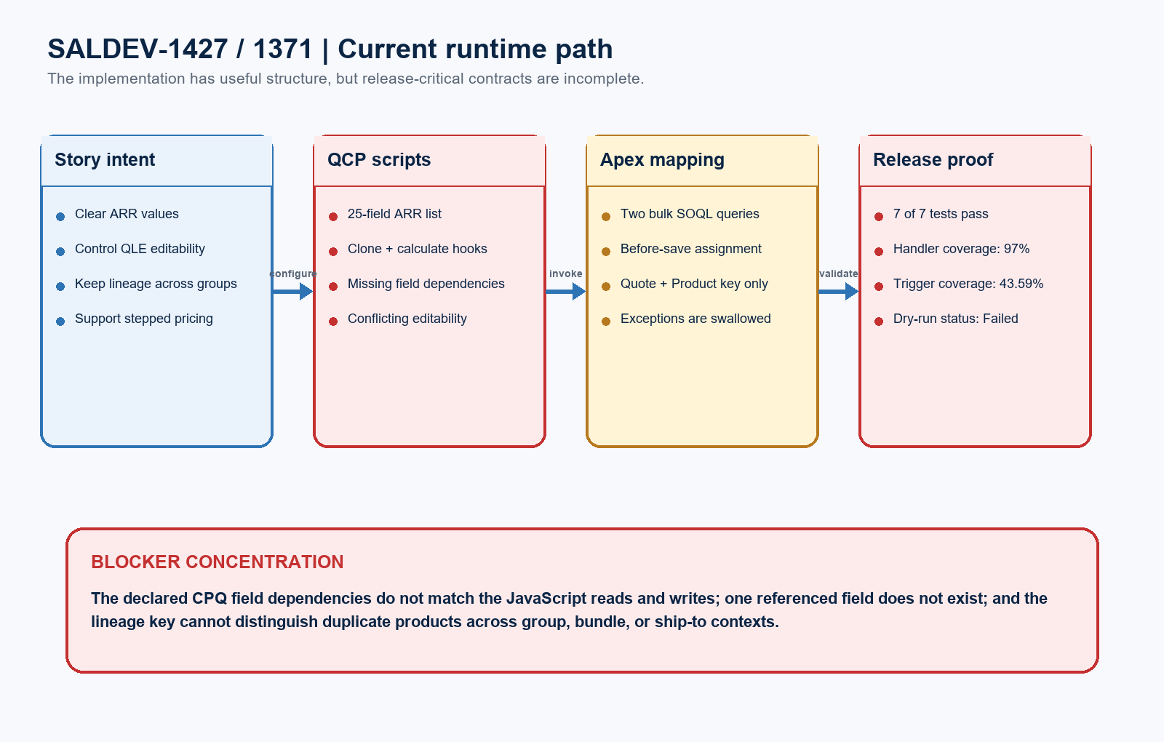
Figure 1. Current implementation path and release-blocker concentration
DESIGN READING
Blue shows the intended contract. Green shows practices worth retaining. Amber marks incomplete proof. Red identifies issues that can create incorrect quote-line behavior or block release.

Detailed code and validation evidence

1. Live component and runtime evidence
Evidence area | Observed result | Evidence
Target org | Verified sandbox | FlywirePartial is org 00DhG0000000jOXUAY; Enterprise Edition; IsSandbox=true.
QCP_HideFieldInQLE | Live runtime present | 1,999 JavaScript lines; transpiled runtime exists; syntax check passed.
QLE_CloneLineHandler | Live runtime present | 58 JavaScript lines; clone hook and runtime exist; syntax check passed.
Apex runtime | Bulk-structured | Trigger delegates to a with-sharing handler using Sets, Maps, and two SOQL queries outside loops.
Field read-back | 24 of 25 found | Domestic_Sponsor__c does not exist; Processed_Volume_Amount__c is correctly excluded.

2. Best-practice findings
Finding | Severity | Evidence
Dependency contract | BLOCKER | Clone script declares only NS ID and Opportunity Line ID; QCP omits required line and group fields.
Rule precedence | BLOCKER | Two usage-rate fields appear in both global read-only and editable-ramping sets; read-only wins.
Lineage determinism | HIGH | Quote + Product occurrence order can cross bundles or ship-to groups; fallback reuses the first master ID.

3. Test and validation evidence
Test / boundary | Status | Evidence
Focused Apex suite | PASS | 7 of 7 QuoteLineTriggerHandlerTest methods passed; zero test failures.
Handler coverage | PASS | QuoteLineTriggerHandler measured 97%; this supports the bulk-structured handler implementation.
Trigger coverage | FAIL | QuoteLineTrigger measured 43.59%; Salesforce requires at least 75% for the selected trigger.
Check-only package | FAILED | 0AfhG000001da33SAA: 3/3 components, 7/7 tests, but coverage gate failed; nothing deployed.
Behavior proof | MISSING | No JavaScript unit suite or live QLE scenario matrix; the second-group Apex outcome is not asserted.

Required target architecture and proof model
The release-ready design should centralize the ARR field contract, declare every QCP dependency, make editability precedence explicit, correlate lineage deterministically, and prove JavaScript plus Apex behavior independently.
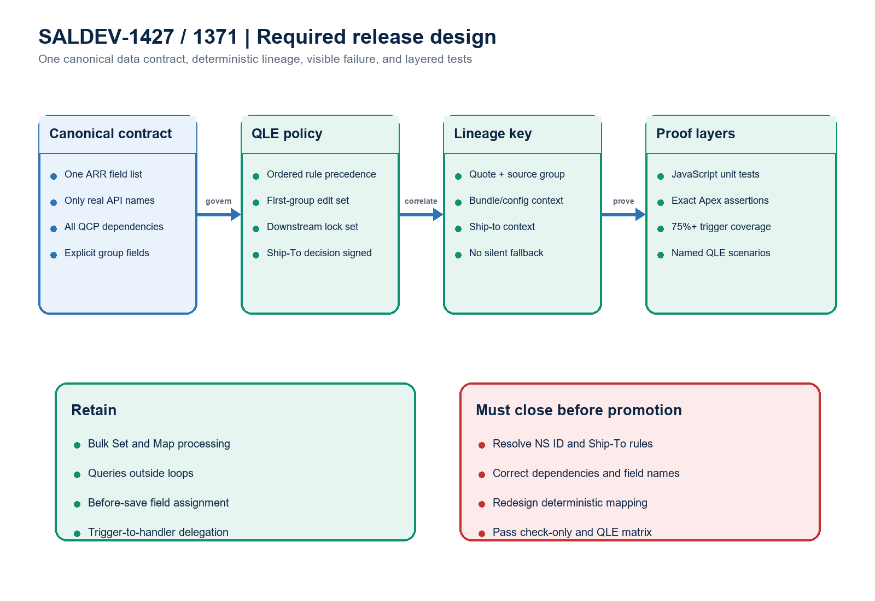
Figure 2. Required data contract, lineage design, and proof layers
Architect interpretation: the code has a sound bulk-processing foundation, but configuration and identity semantics are part of the implementation. Passing handler tests cannot compensate for an invalid field, missing QCP dependencies, ambiguous lineage, or insufficient trigger coverage.

Required completion gates
Gate | Required action | Owner | Evidence needed
1 | Correct field names and QCP dependencies | CPQ Developer | All referenced line/group APIs exist and are declared; remove Domestic_Sponsor__c or map it correctly.
2 | Make editability precedence explicit | CPQ Developer | Usage price fields are editable only where intended; tests cover first and downstream groups.
3 | Redesign lineage correlation | Apex Developer | A deterministic source/group/bundle/ship-to key; no first-ID fallback; visible failure behavior.
4 | Resolve story semantics | Product Owner | Signed decision for NS ID, Ship-To locking, amendment scope, and the SALDEV-1404 dependency.
5 | Add exact automated tests | Developer / QA | JavaScript hook tests plus Apex assertions for every group, duplicate product, bundle, ship-to, and 200-line case.
6 | Re-run release and QLE proof | Dev Lead / QA | 75%+ trigger coverage, successful check-only, and named SUP/non-SUP multi-group functional read-back.

Ready-to-paste architect response
STORY COMMENT
Architect review completed for SALDEV-1427 and duplicate SALDEV-1371 in FlywirePartial. Decision: Changes Requested / NO-GO before QA or promotion. Strengths: both QCP scripts pass syntax checks; the with-sharing handler uses bulk Sets and Maps with queries outside loops; 7 of 7 focused tests passed; and handler coverage is 97%. Blockers: QLE_CloneLineHandler declares only NS ID and Opportunity Line ID although it writes the ARR set; QCP_HideFieldInQLE omits required line and group dependencies; Domestic_Sponsor__c is not a quote-line field; usage-rate fields are both globally read-only and ramp-editable; and lineage uses only Quote + Product, allowing cross-group, bundle, or ship-to mismatches. Exceptions are swallowed. Check-only 0AfhG000001da33SAA validated 3 of 3 components and ran 7 passing tests, but failed because trigger coverage is 43.59%, below 75%. Nothing deployed. Resolve the NS ID, Ship-To, and amendment requirements; correct dependencies and API names; redesign deterministic mapping; add JavaScript and exact Apex assertions; reach 75%+ trigger coverage; and complete the named QLE matrix before resubmission.

Evidence boundary
Evidence: supplied story documents, verified FlywirePartial sandbox and custom scripts, retrieved Apex and field metadata, JavaScript syntax checks, focused tests, and check-only validation. No Salesforce record or metadata changes, deployment, activation, promotion, or Production action occurred.

